WEEK – 5 Assignments
ASP. NET Core 8. 0 Web API
Mandatory hands-on :-
6. WebApi_Handson :
Kafka Integration with C#:
Hands On:
1. Create a Chat Application which uses Kafka as a streaming platform and consume the chat messages in the command prompt.
2. Create a Chat Application using C# Windows Application using Kafka and consume the message in different client applications.

1. Create a Chat Application which uses Kafka as a streaming platform and consume the chat messages in the command prompt :

First app “KafkaChatConsumer” :
Code :
Program.cs :
using System;
using Confluent.Kafka;
class Program
{
static void Main()
{
var config = new ConsumerConfig
{
BootstrapServers = "localhost:9092",
GroupId = "chat-group",
AutoOffsetReset = AutoOffsetReset.Earliest
};
using var consumer = new ConsumerBuilder<Null, string>(config).Build();
consumer.Subscribe("chat-message");
Console.WriteLine("Listening for messages. Press Ctrl+C to exit.");
try
{
while (true)
{
var consumeResult = consumer.Consume();
Console.WriteLine($"Received: {consumeResult.Message.Value}");
}
}
catch (OperationCanceledException) { }
finally
{
consumer.Close();
}
}
}

Second app “KafkaChatProducer” :
Code :
Program.cs :
using System;
using System.Threading.Tasks;
using Confluent.Kafka;
class Program
{
static async Task Main(string[] args)
{
var config = new ProducerConfig { BootstrapServers = "localhost:9092" };
using var producer = new ProducerBuilder<Null, string>(config).Build();
Console.WriteLine("Enter your chat messages (type 'exit' to quit):");
while (true)
{
var msg = Console.ReadLine();
if (msg.ToLower() == "exit") break;
await producer.ProduceAsync("chat-message", new Message<Null, string> { Value = msg });
}
}
}

OUTPUT :
Both Producer side and Consumer side output of chats :
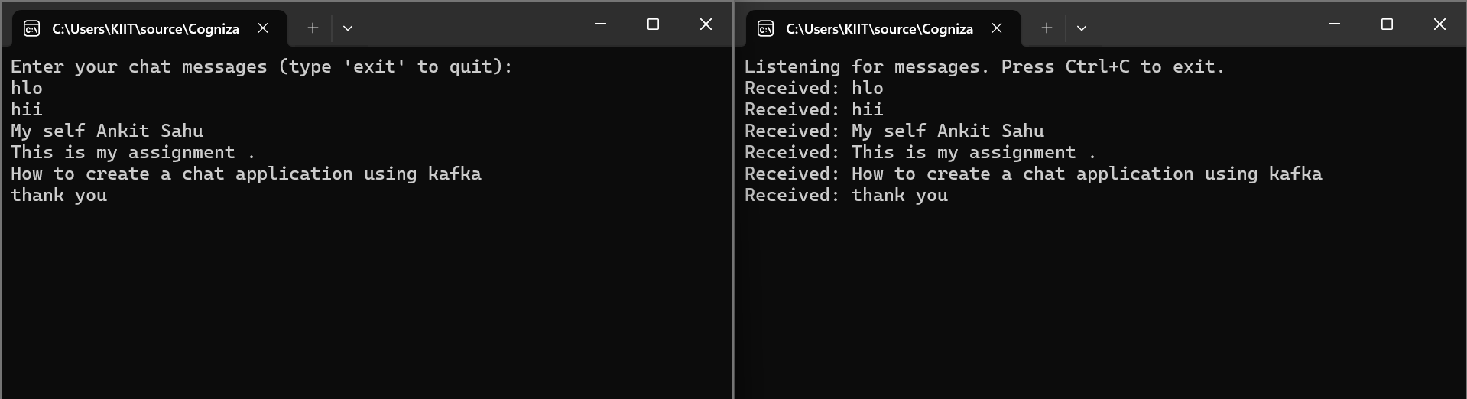

Kafka Server Running:
.\bin\windows\kafka-server-start.bat .\config\server.properties :
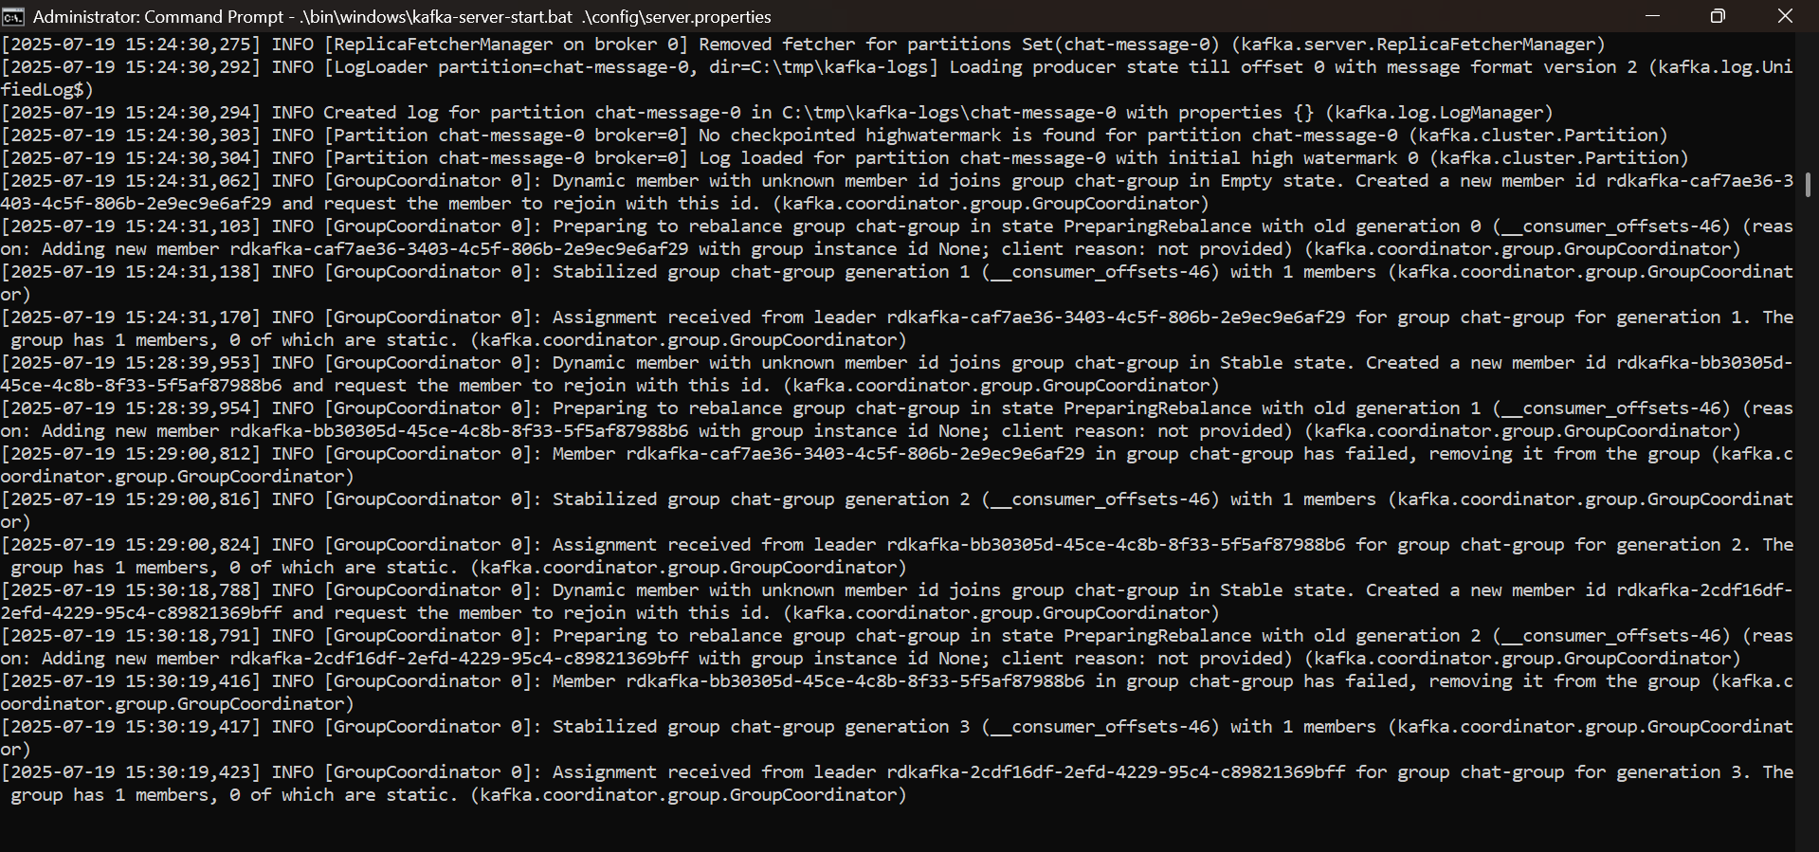

Zookeeper Running:
.\bin\windows\zookeeper-server-start.bat .\config\zookeeper.properties :
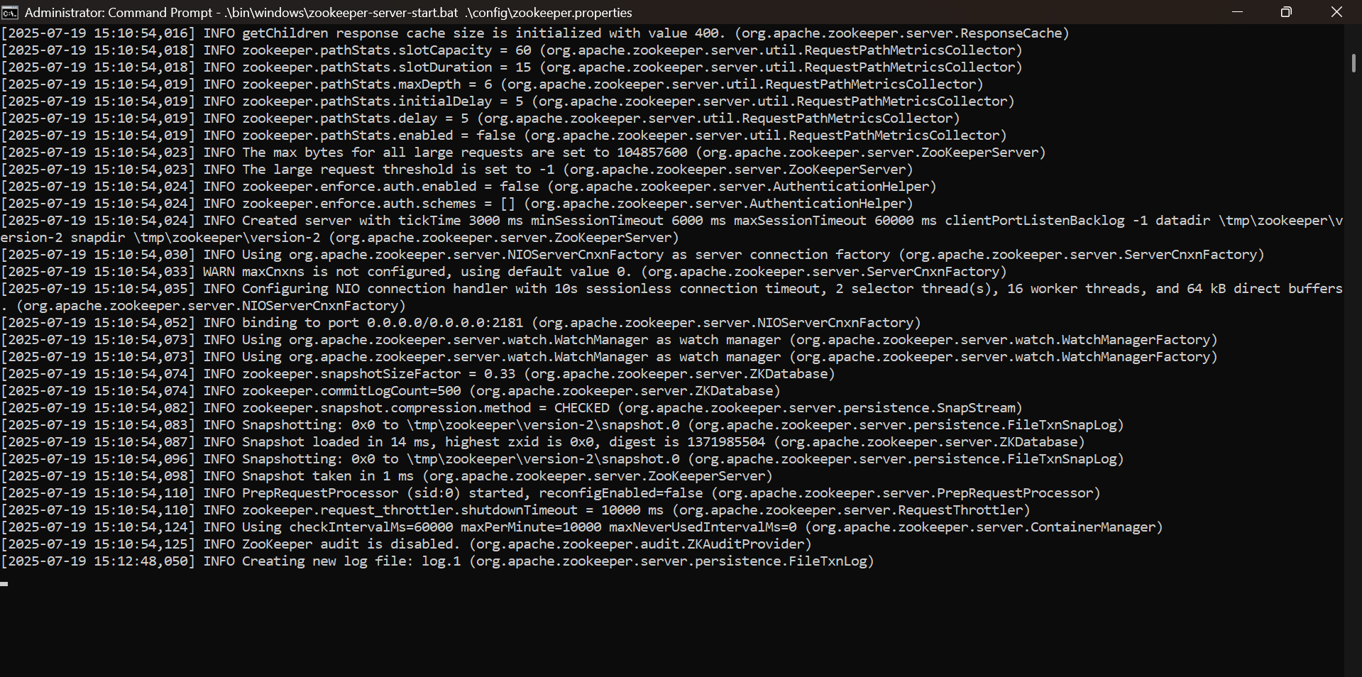

Topic Created :
